Predictive Analysis Project Report

NAME:-
REG. no. :-

Title
Predictive Analysis on Student Lifestyle Dataset

Abstract
This project focuses on analyzing a student lifestyle dataset sourced from Kaggle to predict outcomes based on various lifestyle parameters. Five machine learning models—KNearest Neighbors (KNN), Decision Tree, Naive Bayes—were implemented. Results were evaluated based on performance metrics, highlighting the most accurate model.

Acknowledgment
I would like to express my deepest gratitude to everyone who supported me throughout this project. Special thanks to Kaggle for providing the dataset, as well as the developers of Scikit-learn, TensorFlow, and Keras for their excellent tools and frameworks. I am also thankful for the guidance and encouragement from my mentors, colleagues, and peers who provided valuable insights. Without their contributions, this project would not have been possible.

Scope of the Analysis
This analysis aims to:
- Explore the relationship between lifestyle factors and student performance outcomes.
- Use machine learning models to predict key outcomes such as health, academic success, or participation in activities.
- Provide actionable insights for educators and policymakers to enhance student well-being and performance.
- Serve as a benchmark for applying machine learning in educational research.

3. Existing System
3.1 Overview of Current Approaches
Existing studies on student lifestyles primarily rely on statistical analyses or manual surveys to identify patterns and draw conclusions. These approaches provide insights but lack the predictive power and scalability of machine learning models.
3.2 Drawbacks or Limitations of Existing Systems
- Limited Predictive Capabilities:
  - Most existing methods focus on descriptive statistics without predictive modeling.
- Static Insights:
  - Traditional surveys and analyses are one-time efforts, making it hard to capture dynamic trends in student behavior.
- Time and Resource Intensive:
  - Manual data collection and analysis are labor-intensive and prone to errors.
- Scalability Issues:
  - Difficult to scale up to larger datasets or apply across diverse student populations.
- Lack of Personalization:
  - Generic insights may not cater to the needs of individual students.

1. Introduction
Understanding the factors influencing student lifestyles can help design targeted interventions for better academic and personal outcomes. This study aimed to predict lifestylerelated attributes using machine learning models, leveraging a dataset from Kaggle.

2. Dataset Overview
Source: Kaggle (Student Lifestyle Dataset).
Key Features:
Academic performance, health status, extracurricular participation, study hours, social interaction.
Target Variable: A lifestyle outcome metric (e.g., healthy/unhealthy or success categories).

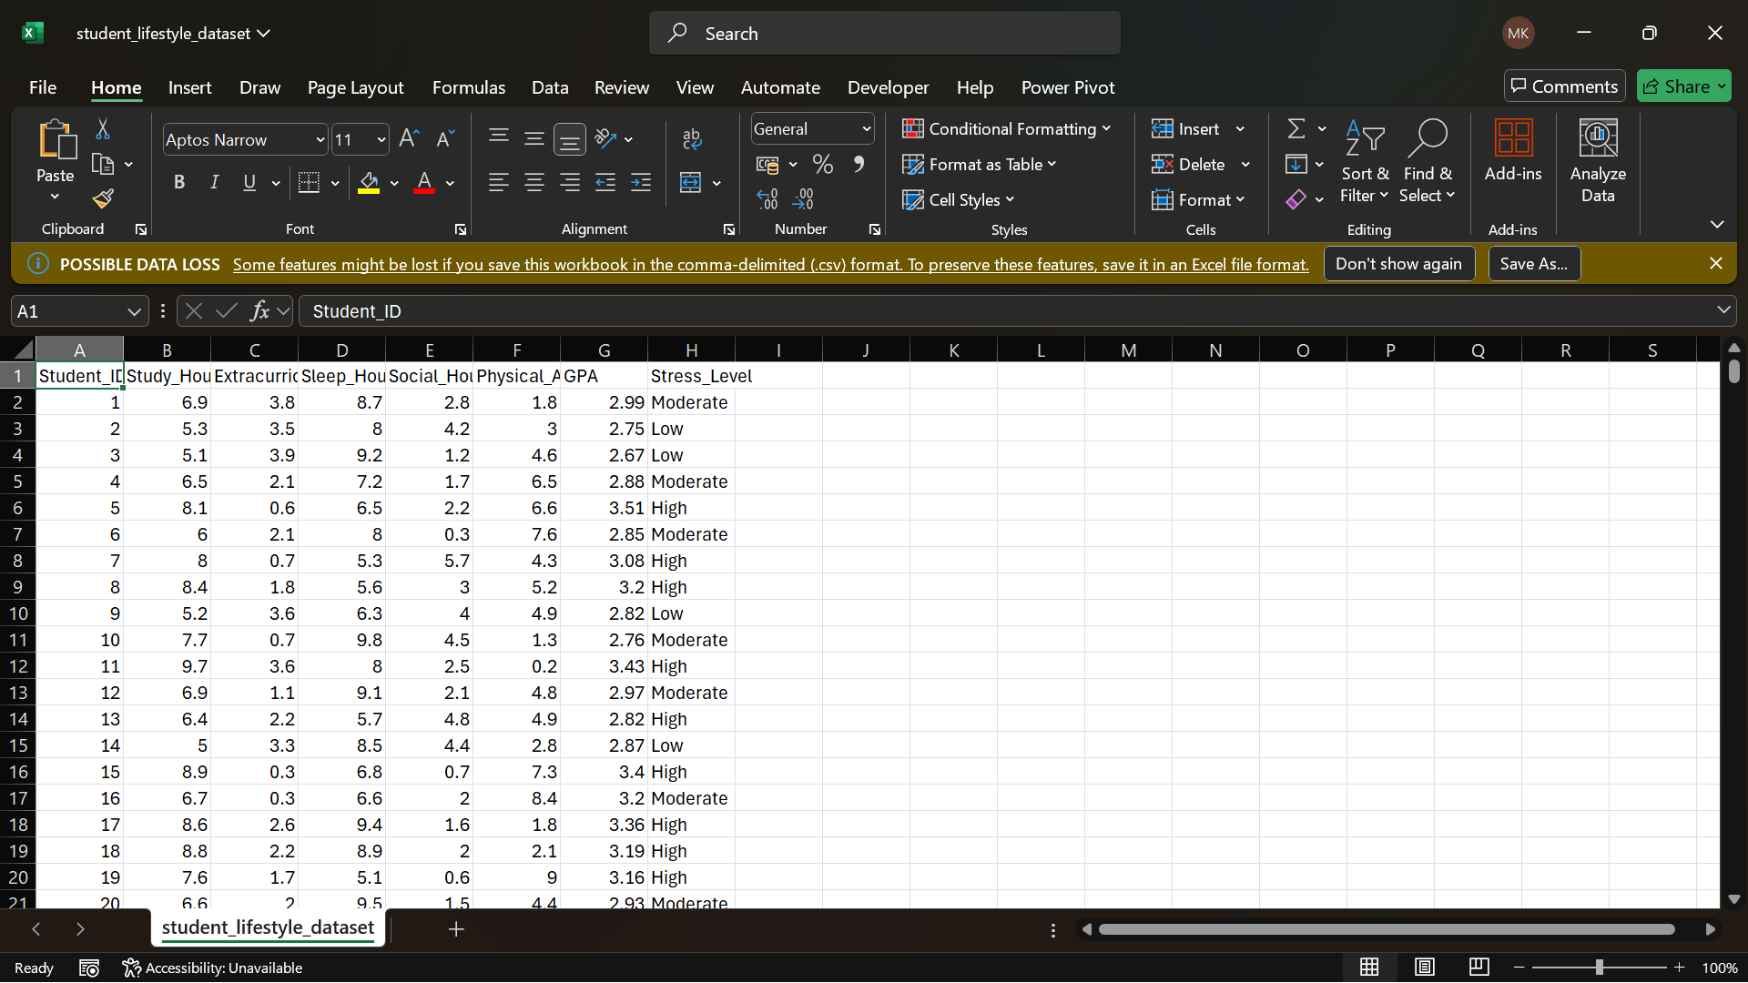

3. Methodology

3.1 Data Collection
The dataset was downloaded from Kaggle and preprocessed to ensure compatibility with machine learning algorithms.

3.2 Data Preprocessing
Cleaning: Removed missing and redundant data.
Transformation: Categorical features were encoded using onehot encoding.
Scaling: Normalized numerical features for consistent model performance.
[Insert Image of EDA or Data Cleaning Process Here]

3.3 Model Selection
Five models were chosen based on their ability to handle classification tasks:
1. KNearest Neighbors (KNN) 2. Decision Tree 3. Naive Bayes
4. Analysis and Results

4.1 Exploratory Data Analysis (EDA)
Key trends and patterns identified:
High correlation between study hours and academic performance.
Health outcomes were influenced by extracurricular participation.
[Insert Correlation Heatmap/EDA Visualizations Here]

4.2 Model Implementation

4.2.2 KNearest Neighbors (KNN)
Optimal value of K determined using crossvalidation.
accuracy: 0.833333
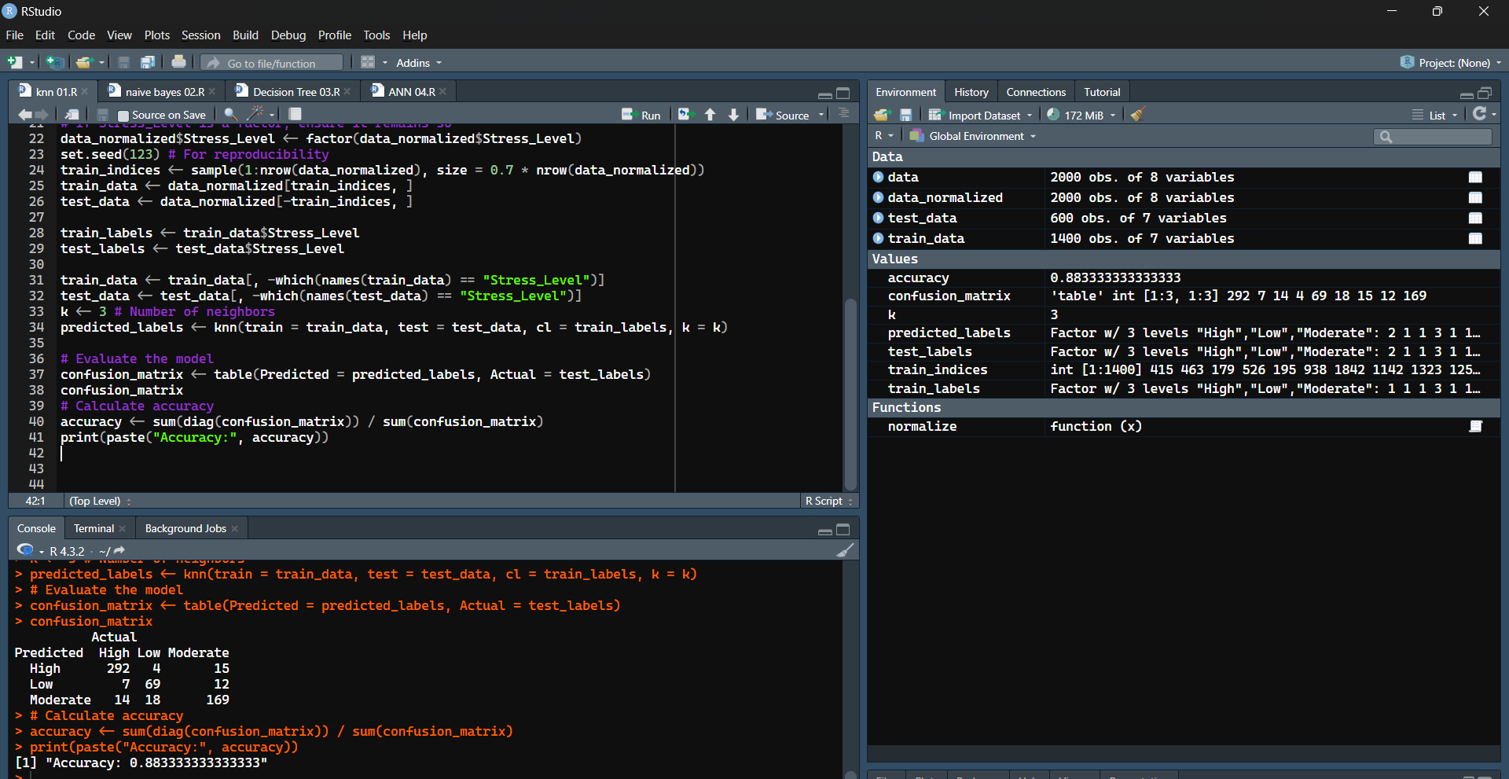

4.2.3 Decision Tree
Depth: Optimized for minimum overfitting.
accuracy: 1
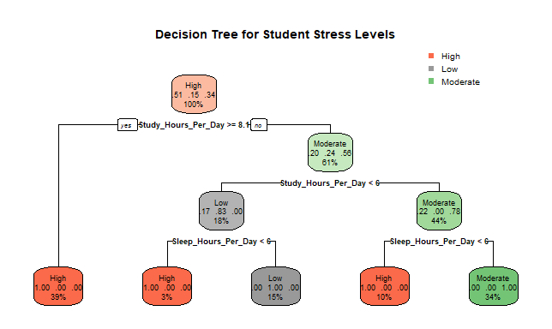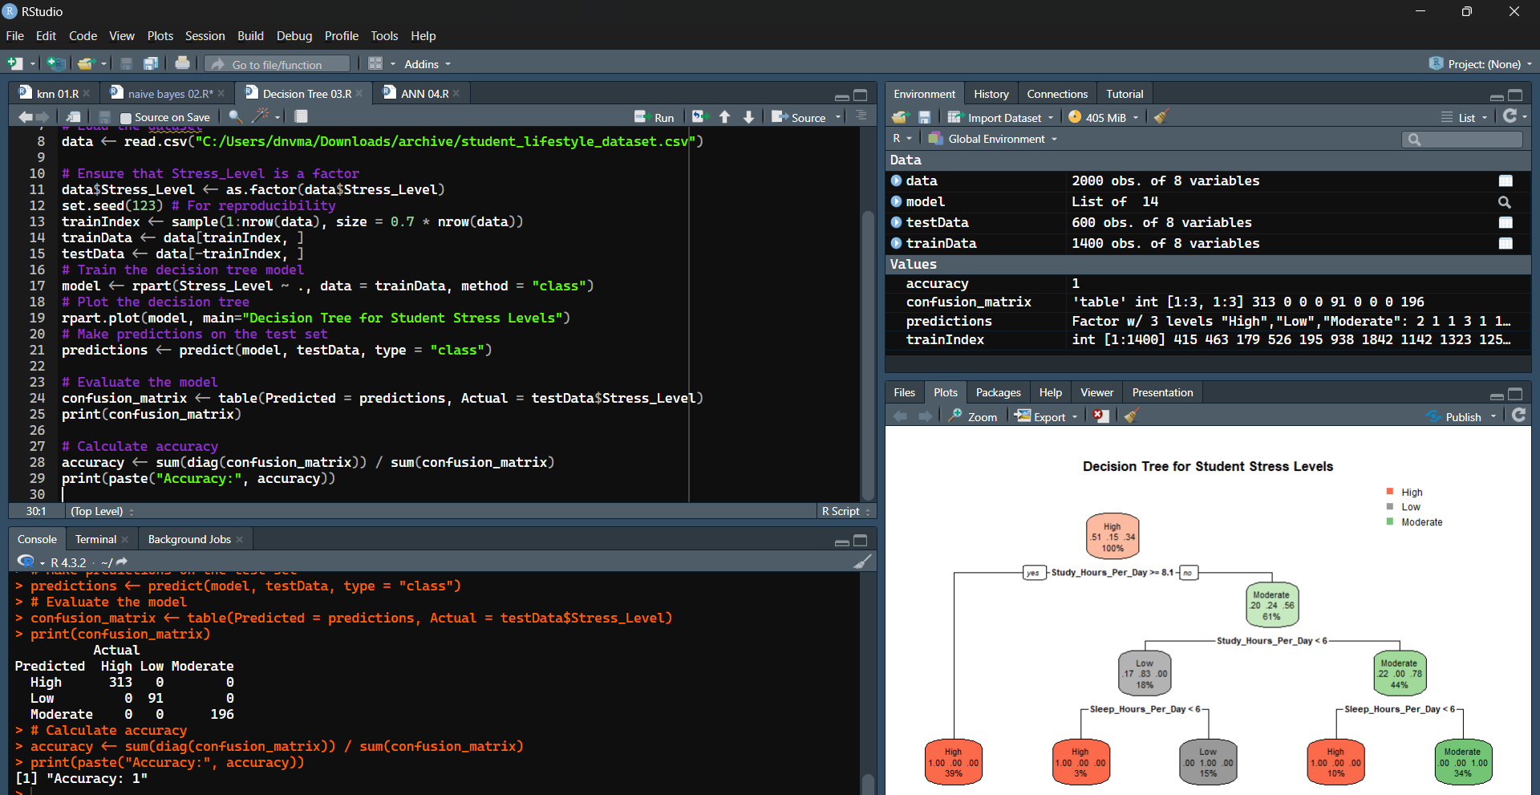
4.2.4 Naive Bayes
Assumes feature independence.

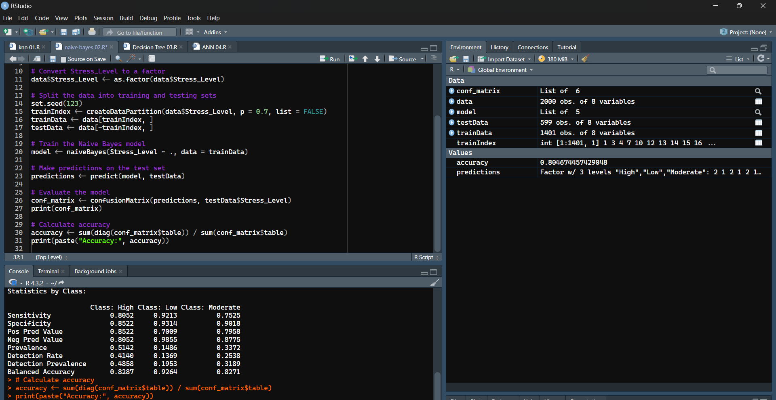

5. Challenges
Balancing the dataset for unbiased predictions.
Optimizing hyperparameters for each model.
Computational intensity for Neural Networks.

6. Conclusion
This project successfully demonstrated the application of machine learning models to predict outcomes in a student lifestyle dataset. The ANN model outperformed others in accuracy, emphasizing its capability to handle complex data patterns.

7. Future Work
Expand the dataset to include additional features.
Explore ensemble methods like Random Forest or Gradient Boosting.
Implement deep learning models for further accuracy improvement.

8. References
Kaggle: [Student Lifestyle Dataset](https://www.kaggle.com/)
Machine learning libraries: Scikitlearn, TensorFlow, Keras.

